Q1**:**

**Inputting password less than 8 characters**

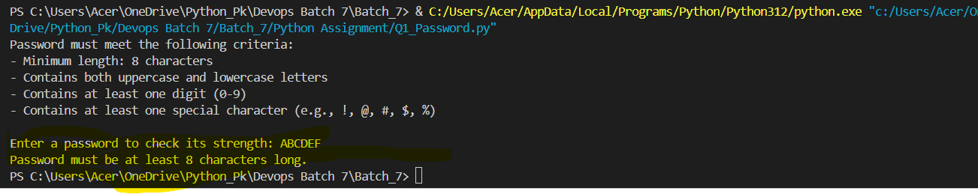

**Inputting password will all alphabets and no upper case:**

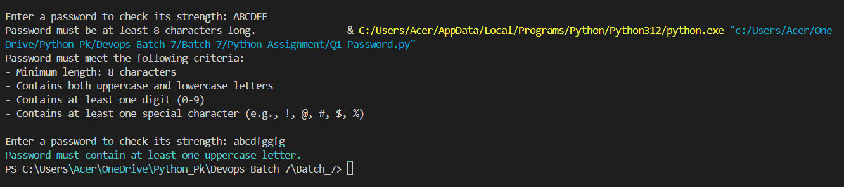

**Inputting password without any special characters:**

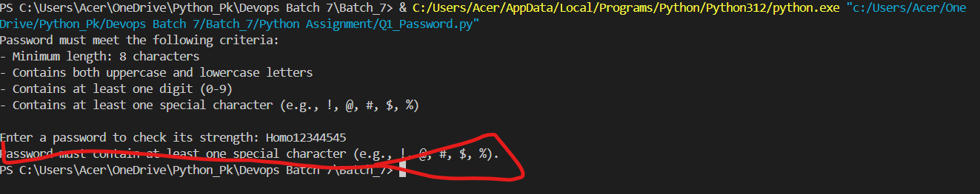

Finally, entering a good password

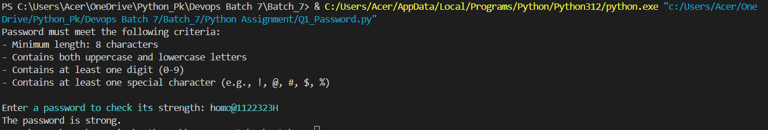

Q2**:**

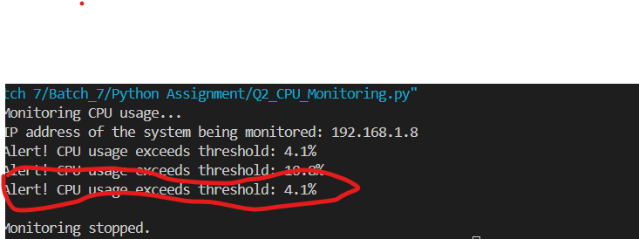

Q3**:**

Q4:

Please see Assignment\backup1 for all the backups created for this script

